Smart Pet Feeder with App-Based Control Integration

An Arduino based project

Submitted in partial fulfillment

of requirements for

APPLICATION DEVELOPMENT AND EMERGING TECHNOLOGY

Submitted to:

Mr. Jomel N. Servidad

Submitted by:

Jaycee Decepida

Chinzy Jay Rock Batilo

Warren Mandario

Reiner Vice Baguna

Khyle Alexander Pabalinas

Jan Justin Kenneth Chua

BSIT2-3

August 2024

Table of Contents

1. Introduction………………………………………………………………………

……………..

1. Statement of the Problem…………………………………………………………………..
2. Objectives……………………………………………………………………………………….

IV. Review of Related Literature…………………………………………………………………

V. Methodology……………………………………………………………………………………….

Diagram………………………………………………………………………………………..

Materials………………………………………………………………………………………..

Procedure………………………………………………………………………………………..

VI. Results and Discussion………………………………………………………………………….

VII.Conclusion and Recommendation………………………………………………………….

VIII.Documentation…………………………………………………………………………………..

Pictures…………………………………………………………………………………………

IX.References……………………………………………………………………………………………

**I. Introduction**

Pets are valued companions, providing emotional support and enhancing family well-being. Ensuring their health is crucial, but managing feeding schedules can be challenging for busy pet owners. Inconsistent feeding can lead to issues like obesity, while a lack of feeding can result in malnutrition.To address these problems,the **Smart Pet Feeder with App-Based Control Integration** offers a modern solution. This system incorporates a NodeMCU ESP8266 microcontroller and servo motors to dispense accurate and precise portions of food,ensuring pets receive the right amount at the right time. Instead of voice commands, the feeder is controlled via a mobile application, allowing pet owners to set specific feeding schedules and manage the feeder remotely.

This technological solution ensures that pets receive consistent and appropriate care, making it easier for owners to maintain their pets’ health despite their busy lifestyles. Ultimately, this innovative feeder enhances pet care and convenience, ensuring that pets are well-nourished and their needs are met.

### 

### **II. Statement of the Problem**

* Busy pet owners often struggle with consistent and accurate pet feeding, risking issues like obesity or malnutrition. Traditional methods lack precision and convenience, highlighting the need for a reliable, automated feeder with app-based control to ensure precise feeding schedules and improve pet care

### 

### 

### **III. Objective**

* Design and implement a Smart Pet Feeder with NodeMCU ESP8266 and servo motors for accurate food dispensing, controlled via a mobile app for easy scheduling and monitoring, to improve pet health and simplify consistent feeding management.

**IV.Review of Related Literature**

**Introduction**

This study explores various studies, articles, and product analyses related to smart pet feeders with app-based control integration, highlighting their features, benefits, and implications.

[1] In "Remote Controlled Movable Pet Feeder Device," Johnson Goh describes a pet feeder that can be controlled from a distance using a software app. The device includes a wireless connection to send and receive data, at least one compartment for storing food, a port for dispensing food, a device for movement, and a control system that communicates with the wireless connection to manage both the movement of the feeder and access to the food compartment. Published on June 14, 2018.

[2] The "Programmable Pet Feeder" by Tessema Gelila Berhan, Worku Toyiba Ahemed, and Tessema Zelalem Birhan (2014) describes an automated pet feeder designed to dispense food at pre-programmed times. The system is primarily time-based, allowing the owner to set specific times for feeding and controlling the quantity of food dispensed. It uses a microcontroller for system control, an LCD screen to display user inputs, and a buzzer to alert the pet when it’s time to eat. A stepper motor regulates the speed of food dispensation, while a turntable with multiple sections holds different types of food. The owner can select which type of food is dispensed at each mealtime, making the system flexible and programmable.

[3] Automatic smart pet feeders provide convenience and peace of mind for busy or traveling owners by ensuring pets are fed on time and in the correct portions, which supports their health, especially for pets with specific dietary needs. These devices help establish consistent feeding routines, promoting healthier eating habits and reducing overeating. Additionally, features like remote monitoring and interaction strengthen the bond between pets and owners, even when apart. By offering convenience, precision, and fostering proactive pet care, these feeders are contributing to market growth and improving pet care.

## 

## 

## 

## 

## 

## 

## **V. Methodology**

### **Diagram**

### 

**Flow of device**

The ESP8266 initializes, connects to Wi-Fi, and sets up the Blynk app.

Waiting for Commands: The device is ready to receive commands from the Blynk app.

Command Handling:

V0 (Manual Feed): Activating V0 moves the servo to 90 degrees for feeding. A 5-second tone plays during feeding. After 2.5 seconds, the servo returns to 180 degrees, and a different tone plays.

V3 (Set 8 AM Feeding): Activating V3 sets automatic feeding at 8:00 AM. A notification confirms that 8:00 AM feeding is enabled.

Time Check for 8:00 AM: If it’s 8:00 AM, the servo moves to 90 degrees to dispense food, followed by a notification.

V4 (Set 4 PM Feeding): Activating V4 sets automatic feeding at 4:00 PM. A notification confirms that 4:00 PM feeding is enabled.

Time Check for 4:00 PM: If it’s 4:00 PM, the servo moves to 90 degrees to dispense food, followed by a notification.

Looping: The device returns to the waiting state after each feeding action.

### 

### 

### **Materials**

* NodeMCU ESP8266 Microcontroller
* Servo Motor
* Power Supply
* Feeder Cover
* Mobile Application (developed for iOS/Android)
* Buzzer

### 

### **Procedure**

1. **Hardware Assembly:** Connect the servo motor to the NodeMCU as per the schematic.
2. **Software Development:** Write and upload the firmware using the Arduino IDE.
3. **Mobile App Development:** Create the mobile application to manage feeding schedules and control the feeder.
4. **Testing:** Conduct tests to ensure accurate food dispensing and remote management functionality.

## 

## 

## **VI. Results and Discussion**

Upon implementation, the Smart Pet Feeder successfully dispenses food at scheduled intervals, and the mobile application provides real-time monitoring of food levels. User feedback indicates a significant improvement in managing feeding routines and maintaining pet health.

## 

## 

## 

## 

## **VII. Conclusion and Recommendation**

In conclusion, the Smart Pet Feeder with App-Based Control Integration successfully addresses the challenges faced by busy pet owners in managing their pets' feeding schedules. By leveraging the capabilities of the NodeMCU ESP8266 microcontroller and servo motors, the project demonstrates an effective and user-friendly solution for ensuring pets receive the correct portions of food at designated times. The mobile application facilitates real-time monitoring and control, allowing owners to manage their pets' nutrition from anywhere, thus enhancing their overall well-being.

User feedback highlights a significant improvement in feeding consistency and pet health, showcasing the potential of smart technology in pet care.

## 

## **VIII. Documentation**

**Components**

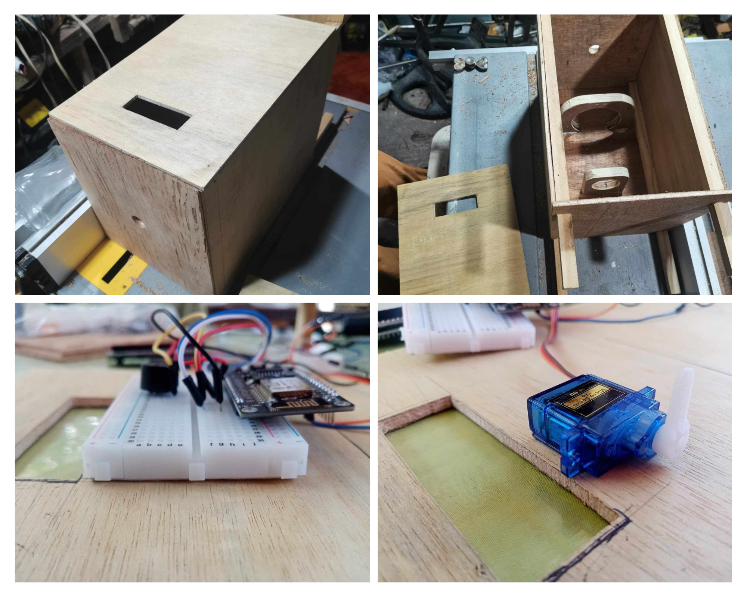

**Circuit Diagram**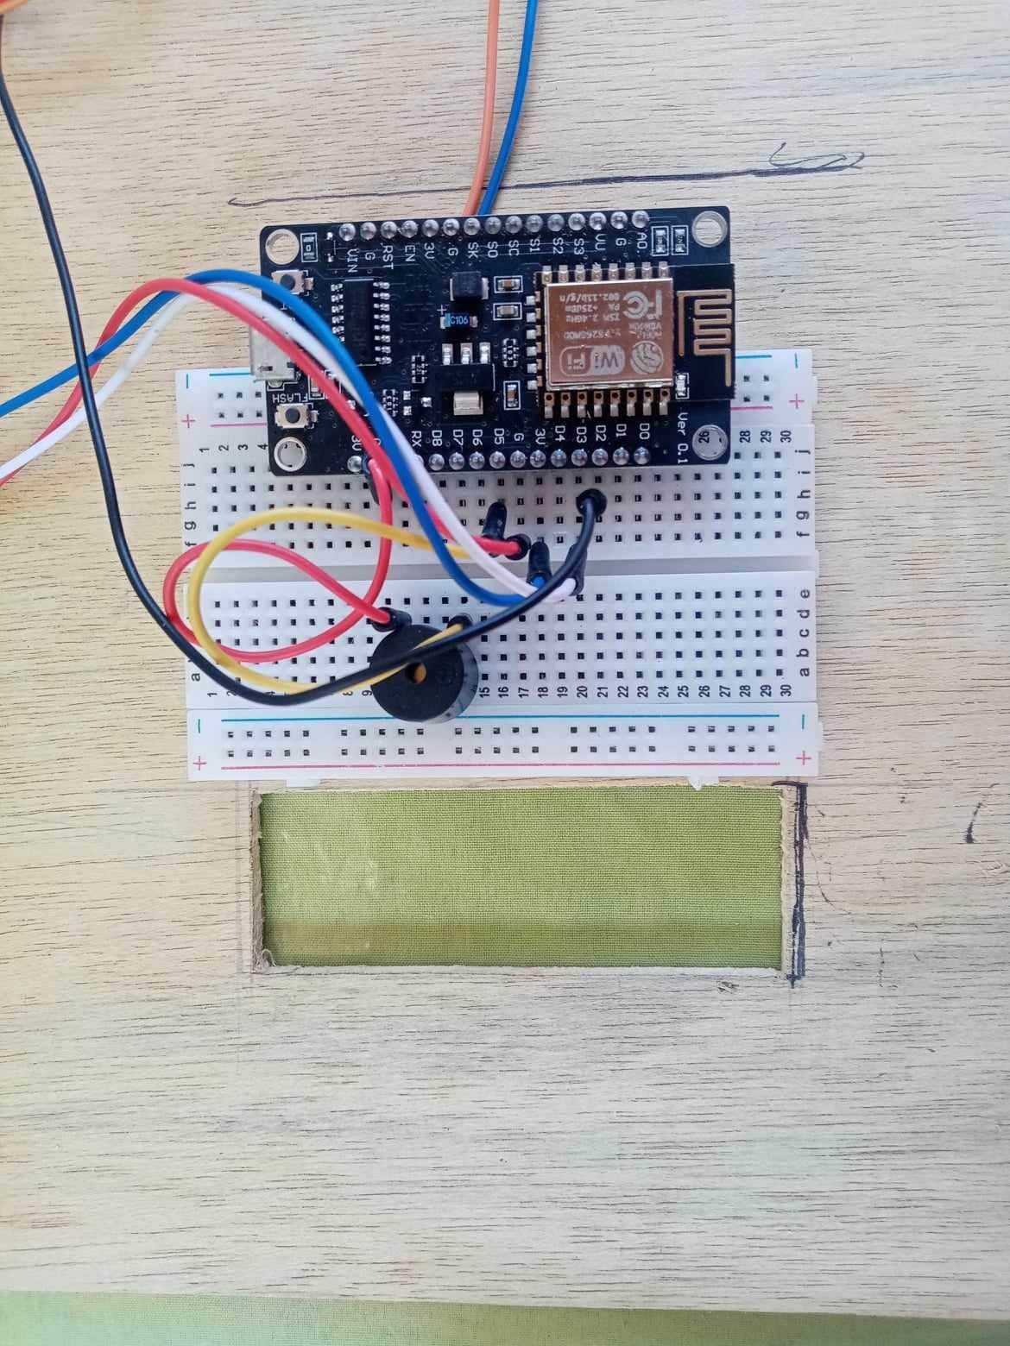

**Code Overview**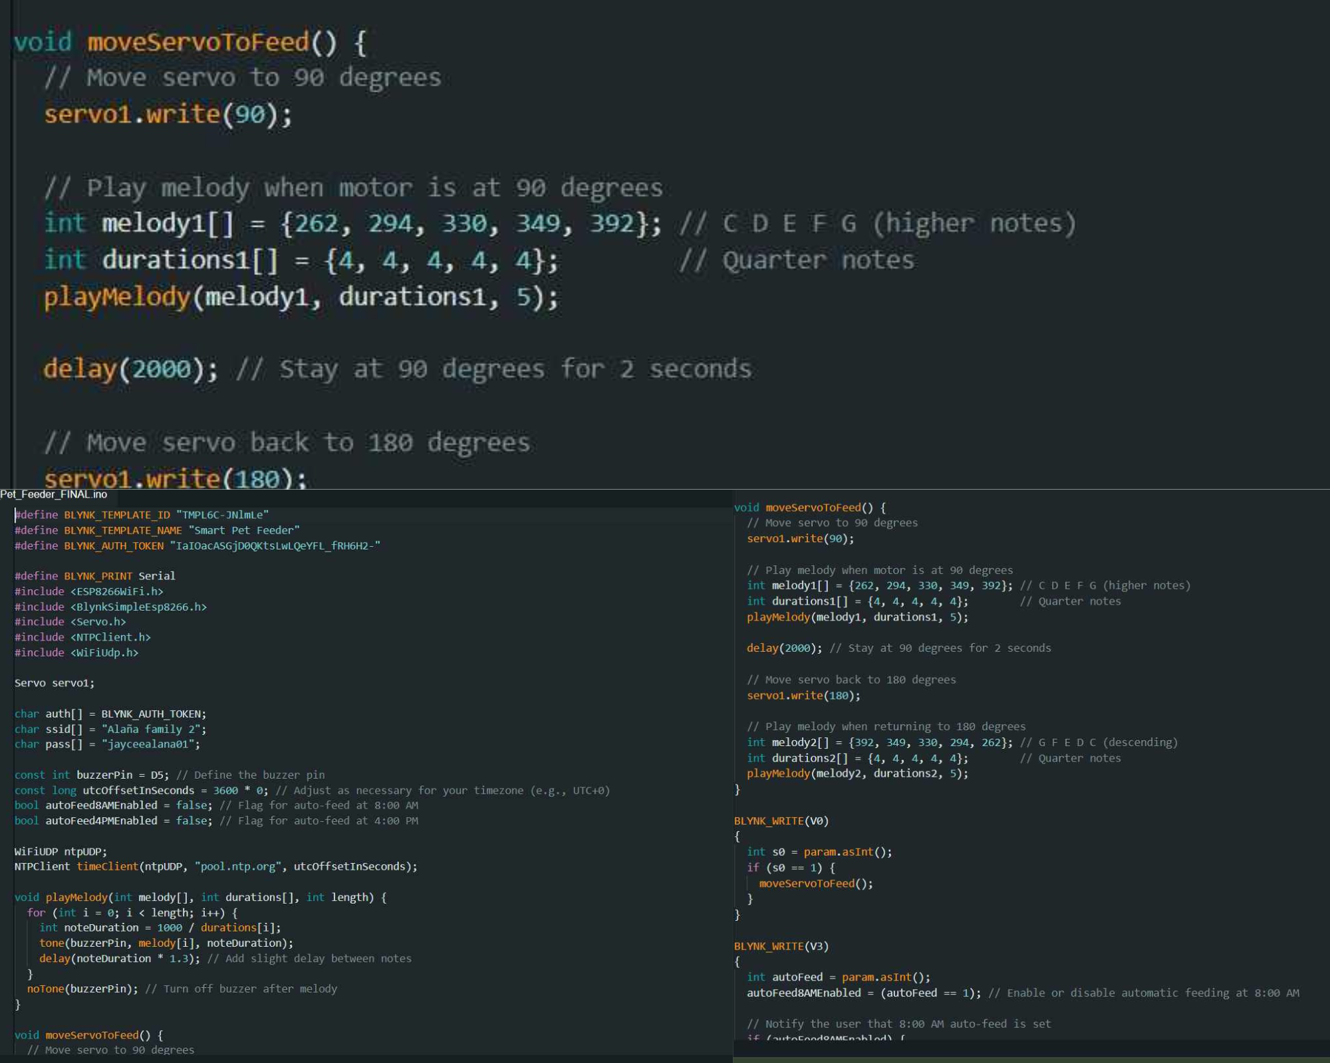

**Testing the Feeder**

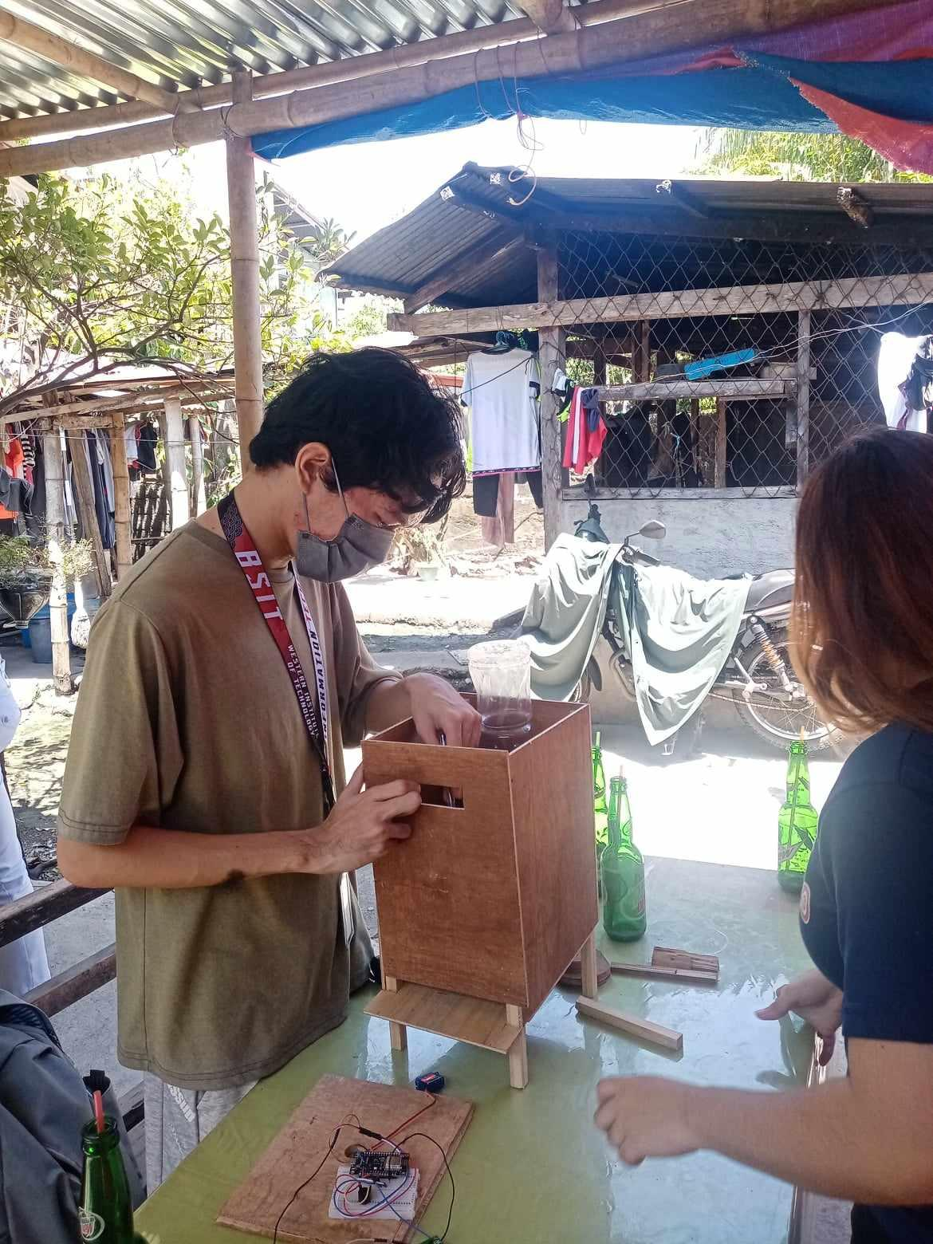

**Desktop Control**

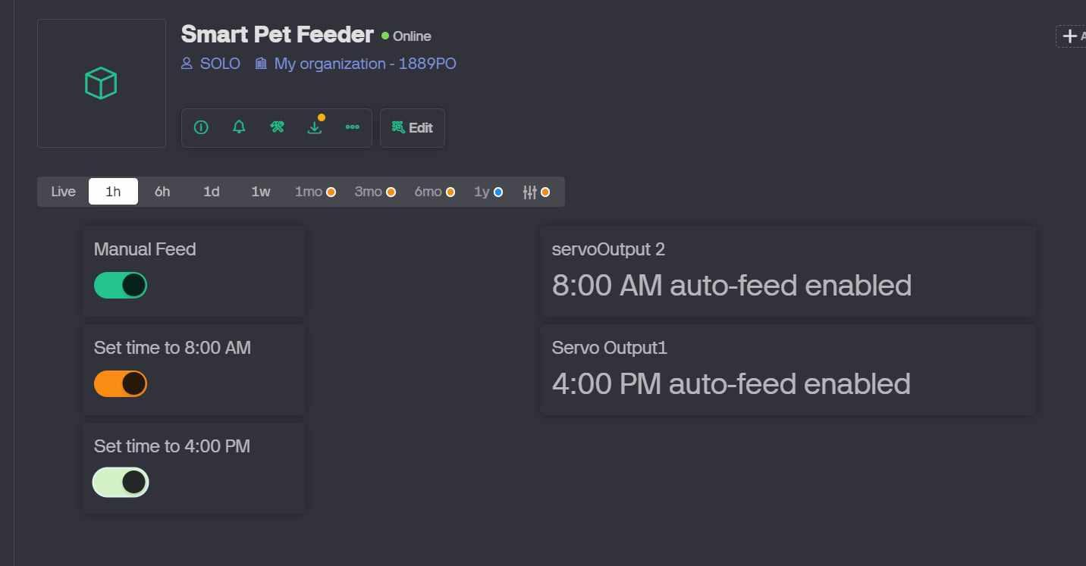

**App Based Control**

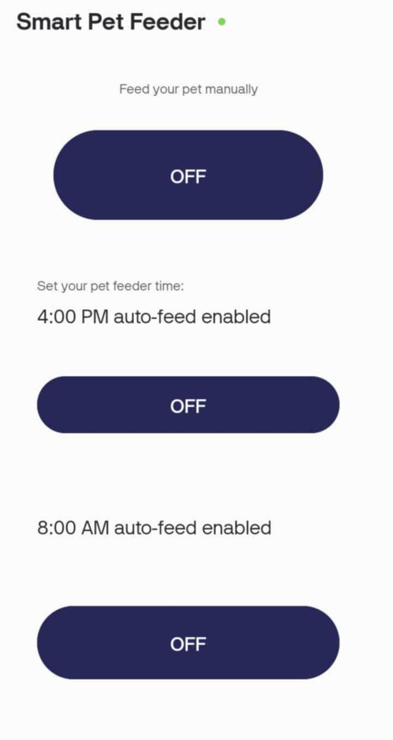

**Final Result**

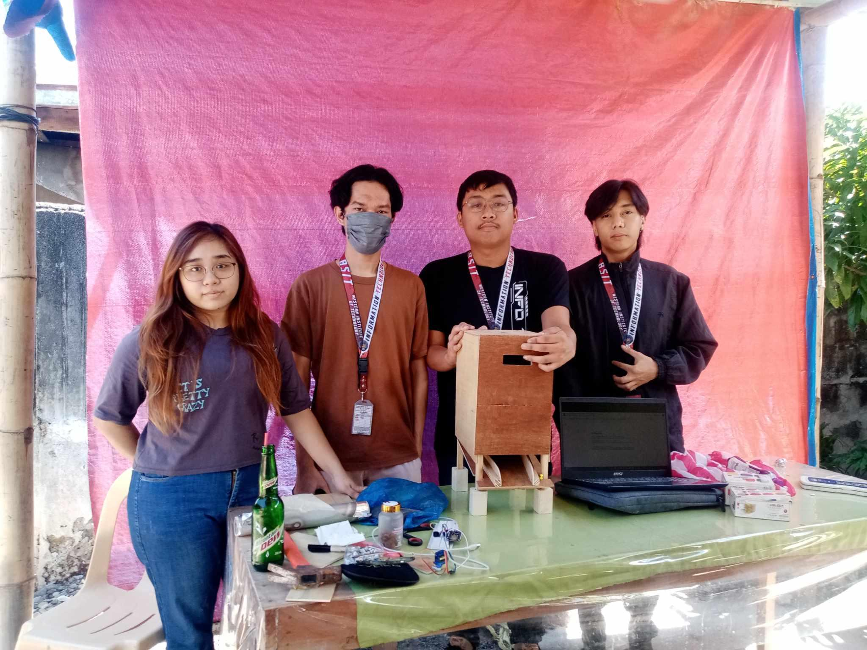

**IX. References:**

[1] Automatic Pet Feeder - Search eLibrary :: SSRN - October 20, 2018

Kank, Aas: <https://papers.ssrn.com/sol3/papers.cfm?abstract_id=3274472>

[2] Seventh Sense Research Group - April 12, 2021 <https://www.internationaljournalssrg.org/IJECE/2019/Volume6-Issue11/IJECE-V6I11P102.pdf>

[3] Precedence Research - February2024

<https://www.precedenceresearch.com/automatic-and-smart-pet-feeder-market#:~:text=The%20application%20of%20automatic%20and,and%20in%20the%20right%20amounts>.